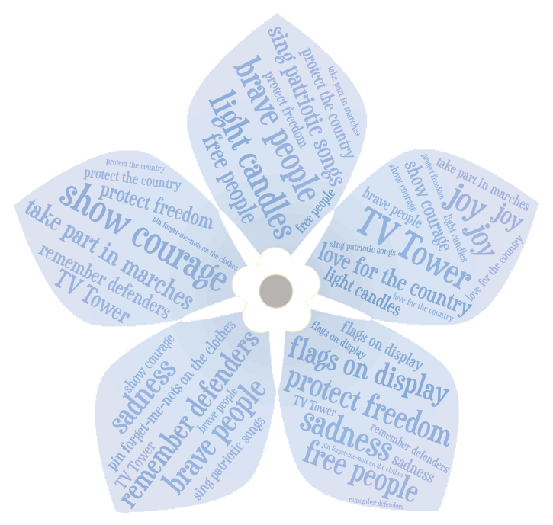

***January 13th***

***the Day of***

***the Defenders of Freedom in Lithuania***

1. *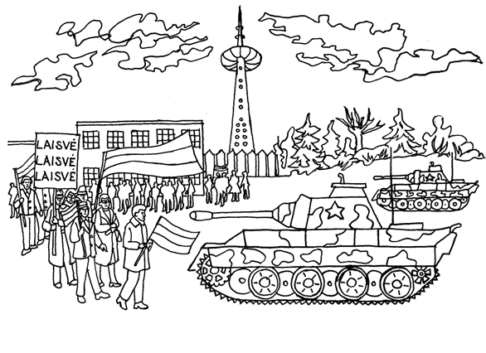***Fill in the words:**

***love for the country - miłość do kraju***

***show courage - pokazać odwagę***

***protect the country - chronić kraj***

***defend freedom - bronić wolności***

***remember the brave people - pamiętać o odważnych ludziach***

***TV Tower - Wieża telewizyjna***

***defenders of freedom - obrońcy wolności***

January 13th is a very special day in Lithuania. It is called **the** **Day of the 1) …………………… of Freedom**. On this day, Lithuanians remember 2) …………………………….. who fought *(walczyli)* to 3) …………… the country. In 1991, many men and women stood up *(wstali)* to 4) ………………….... They 5) showed great ………………… and 6) ………………………….. . Fourteen people died near the 7) ………………………..

***light candles – zapalać świece  
sing patriotic songs - śpiewać pieśni patriotyczne***

***take part in marches – brać udział w marszach***

***pin Forget-me-nots on the clothes - przypinać niezapominajki do ubrań***

***flags on display - flagi na wystawie***

Every year Lithuanians gather *(zbierają się)* to remember these heroes. They take part in 8) …………………. in the main streets of the city and sing 9) ……………………… songs. Lithuanian flags are 10) ………………………. on every building in Lithuania. People light 11) ……………… in the windows and pin 12) …………………………….. on the clothes. These flowers symbolize love and remembrance. Remember why you are free today!

**2. Answer the questions:**  
1. What is the name of the day on January 13th?  
............................................................................................................................................................  
2. Where and how many people died in 1991?  
............................................................................................................................................................  
3. What do people do to remember this day?  
....................................................................................................................................................................................................................................................................................................................................................................................................................................................................................

